INSTRUCTIONS: This is an SOP template; it is complete when
1) All form fields have been completed to reflect chemical/lab-specific information, including adding relevant procedure information, or deleted inapplicable information; and
2) SOP has been signed and dated by the PI and relevant lab personnel.
Use safety data sheets (SDSs) as a resource for chemical-specific information. Text highlighted in gray indicates where information should be added or edited. Delete all instructions in red text and “Draft” watermark after the SOP is approved by PI.

Standard Operating Procedure

Perchloric Acid
Section 1 – Lab-Specific Information
Building/Room(s) covered by this SOP:
Unit or department:
Principal Investigator Name:
Principal Investigator Signature/Date:
This SOP was created by (if not PI):
Name/Title/Date/Signature

Section 2 – Hazards
Perchloric acid is extremely corrosive. It is harmful if inhaled, ingested, or absorbed through the skin. Inhalation may cause irritation to the respiratory tract with burning pain in the nose and throat, coughing, wheezing, shortness of breath and pulmonary edema. Contact with skin causes burns and irritation. Eye contact causes burns, irritation, and may cause blindness. Ingestion may cause permanent damage to the digestive tract. Perchloric acid is destructive to the tissue of the mucous membranes and upper respiratory tract.
Concentrations greater than 50% are considered as “highly dangerous.” At concentrations >72%, perchloric acid is a strong oxidizer. Although not flammable itself, concentrated perchloric acid may ignite other combustible material and increase the intensity of a fire. Anhydrous (dehydrated) perchloric acid, or solutions with concentrations >85%, present a serious explosion hazard. At these concentrations, perchloric acid is unstable and can decompose explosively or spontaneously combust at ordinary temperatures if mixed with organic compounds.
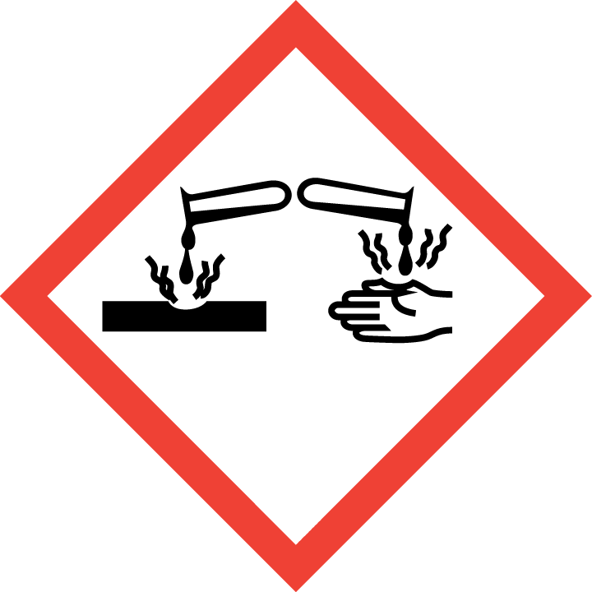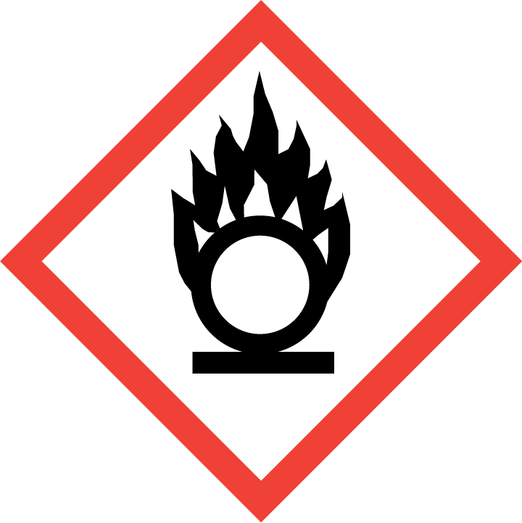
Section 3 – Engineering and Personal Protective Equipment (PPE)
Engineering Controls: The use of perchloric acid at concentrations <72% and at normal temperatures should be conducted in a properly functioning chemical fume hood. The chemical fume hood must be approved and certified by EH&S. Use a specialized perchloric acid fume hood with built in wash down systems and non-reactive metal surfaces when working with concentrations of 72% or above, performing digestions, heating, or mixing with strong dehydrating chemicals (concentrated sulfuric acid, anhydrous phosphorus pentoxide) any concentration of perchloric acid. Perchloric hoods should be washed down every day or more often according to manufacturer’s instructions, depending on frequency and type of use. Put a sign on these hoods to distinguish them from other types of hoods and designate the hood as an area where organic chemicals are prohibited. Keep container lids tightly closed whenever possible. Solvents must never be used or stored in a dedicated perchloric acid fume hood.
Hygiene Measures: Avoid contact with skin, eyes, and clothing. Wash hands before breaks and immediately after handling perchloric acid.
Hand Protection: Two-sets of chemical-resistant gloves (e.g., nitrile or neoprene) should be worn (“double-gloving”). A heavy-duty glove, such as butyl rubber, Viton, or equivalent, is recommended. Use gauntlet gloves if working with anhydrous perchloric acid. NOTE: Consult with your preferred glove manufacturer to ensure that the gloves you plan on using are compatible with the specific chemical being used.
Eye Protection: ANSI-approved properly fitting safety glasses or chemical splash goggles are required. A face shield must also be worn.
Skin and Body Protection: Laboratory coats must be worn, appropriately sized for the individual, and buttoned to their full length. A chemical-resistant/rubber apron is also required. Personnel must also wear full length pants, or equivalent, and close-toed shoes. Full length pants and close-toed shoes must be worn at all times by all individuals that are occupying the laboratory area. The area of skin between the shoe and ankle must not be exposed.
Respiratory Protection: Perchloric acid should never be used outside of a chemical fume hood; however, if perchloric acid must be used outside of a chemical fume hood, respiratory protection may be required. If this activity is necessary, contact EH&S at 206.616.8801 so a respiratory protection analysis can be performed.

Section 4 – Special Handling and Storage Requirements
- Do not over purchase; only a minimum amount of perchloric acid should be stored in the laboratory.
- Avoid contact with skin and eyes. Avoid inhalation of vapor or mist. Avoid formation of dust (explosion hazard!).
- Always use inside a properly functioning chemical fume hood.
- Note: In case you need to dilute the concentration of perchloric acid, always add acid to water.
- Keep container upright and tightly closed in acid storage cabinet.
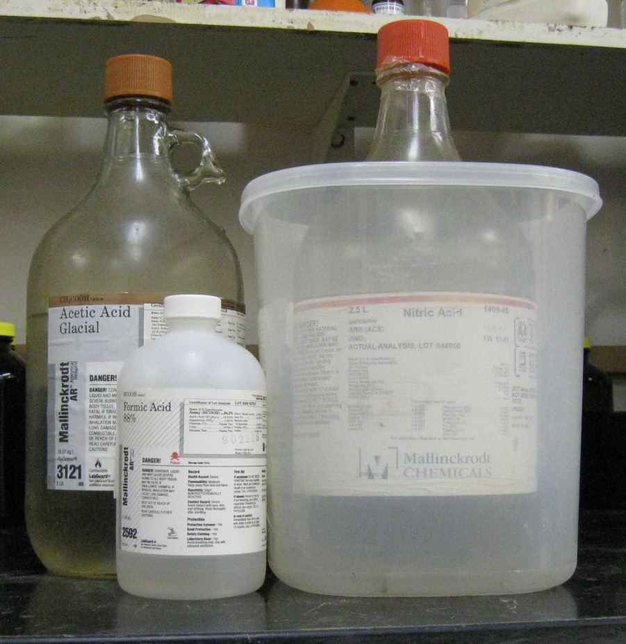
- Containers which are opened must be carefully resealed and kept upright to prevent leakage. Date all opened perchloric acid containers.
- Keep away from sources of ignition. Avoid heat, sparks, shock or friction when handling.
- Store in original container and inside proper secondary containment made of glass or porcelain. Perchloric acid should not be stored in metal or plastic containers.
- Keep away from incompatible materials: acetic acid, acetic anhydride, alcohols, aniline, bismuth, combustible material, dehydrating agents, hydrochloric acid, organic chemicals, and oxidizers. As such, perchloric acid should be stored away from these chemicals, as well as wood or paper, within a steel cabinet, if possible.
Organic acid
Oxidizing acid
- Use in the smallest practical quantities for the experiment being performed. Make up concentrated solutions in amounts that will be used up in the workshift/day.
- Inspect containers monthly for discoloration. Submit a Chemical Waste Collection Request for any discolored perchloric acid.
- Use open bottles of perchloric acid within one year. Submit old bottles for Chemical Waste Collection.
- Make a current copy of the SDS for perchloric acid available to all personnel working in the laboratory at all times.
- Keep containers closed when not in use.
- Transport all corrosives in secondary containment, such as glass or porcelain.

Section 5 – Spill and Accident Procedures
If skin is exposed to perchloric acid, remove clothing and rinse for 15 minutes in the safety shower. Send someone to call 911 as soon as possible. If eye is exposed to perchloric acid, call 911 as soon as possible and flush eyes for 15 minutes in the eye wash. If perchloric acid is inhaled, remove to fresh air and call 911.
Immediately evacuate area if fumes present a serious health risk and ensure others are aware of the spill. During normal business hours (Monday – Friday, 8 AM – 5 PM), call EH&S at 206.543.0467 for further assistance. If it is after hours, call 911 for further assistance. If it is safe to clean up the spill, wear PPE listed above. Dilute spill with water and use sodium carbonate to neutralize the spill. Clean up neutralized spill with sponges, spill pads or paper towels. Double bag and securely fasten spill materials. Label as hazardous waste. Do not attempt to soak up the spill using organic materials, such as Kimwipes or paper toweling, as they may cause the perchloric acid to spontaneously ignite. Do not absorb the spill without neutralizing first. If rags or paper towels are inadvertently used, wet them with water and place them in a tightly sealed plastic bag. Label bags as hazardous waste.
Report the spill via the EH&S Online Accident Reporting System (OARS).

Section 6 – Waste Disposal Procedures
Store waste perchloric acid in closed containers that are properly labeled, and in a designated area. The spill materials cannot go in the trash. Request chemical waste collection via the EH&S website immediately. Accumulate waste in a plastic or Teflon container with a screw top lid. Perchloric acid waste should be segregated from all incompatibles. No perchloric acid wastes are permitted to be poured down the drain.

Section 7 – Protocol
Click here to enter text.
NOTE: Any deviation from this SOP requires approval from Principal Investigator.

Section 8 – Documentation of Training (signature of all users is required)
Prior to conducting any work with perchloric acid, the Principal Investigator must ensure that all laboratory personnel receive training on the content of this SOP.
I have read and understand the content of this SOP:
Name | Signature | Date

