INSTRUCTIONS: This is an SOP template; it is complete when
1) All form fields have been completed to reflect chemical/lab-specific information, including adding relevant procedure information, or deleted inapplicable information; and
2) SOP has been signed and dated by the PI and relevant lab personnel.
Use safety data sheets (SDSs) as a resource for chemical-specific information. Text highlighted in gray indicates where information should be added or edited. Delete all instructions in red text and “Draft” watermark after the SOP is approved by PI.

Standard Operating Procedure

Metallic Lead

Section 1 – Lab-Specific Information
Building/Room(s) covered by this SOP:
Unit or department:
Principal Investigator Name:
Principal Investigator Signature/Date:

Section 2 – Hazards
REQUIRED -Identify the stock chemicals, intermediates, final compounds and wastes involved, and such factors as use of catalysts or inert compounds.
Obtain hazard information from SDS. Include regulatory information since chemical is a particularly hazardous substance.
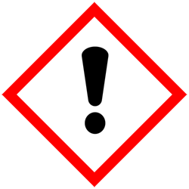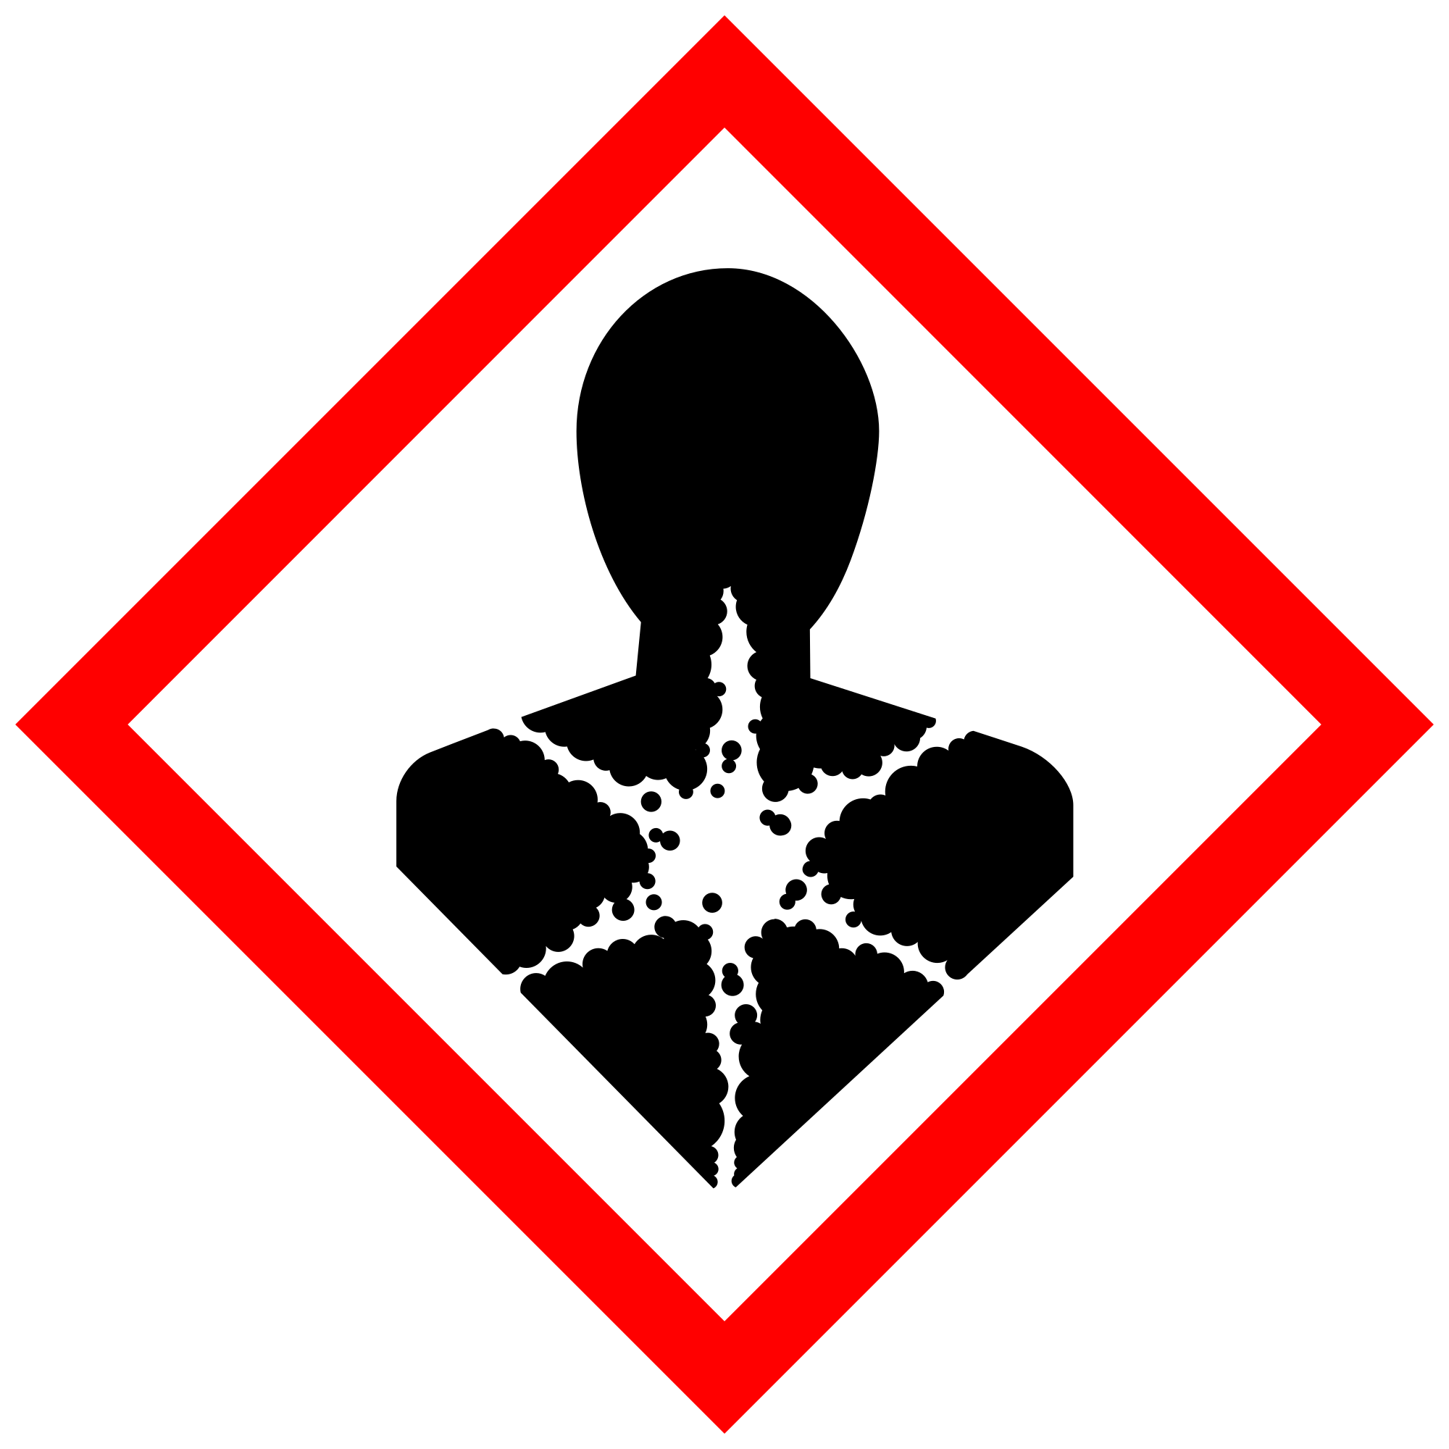
DANGER! Causes damage to kidneys, blood-forming systems, central nervous system and digestive tract through prolonged or repeated exposure. May damage the unborn child. May cause harm to breast-fed children. Suspected of damaging fertility. Suspected of causing cancer.
The World Health Organization’s International Agency for Research on Cancer classifies lead as a Group 2A Carcinogen, meaning it is Probably Carcinogenic to Humans.
The primary routes of exposure to lead are ingestion of lead due to surface contamination and inhalation of lead dust, salts, or fumes.
Short-term over-exposure to lead can cause eye/skin irritation, abdominal pain, digestive problems, fatigue, headaches, irritability, loss of appetite, memory loss, pain, or tingling in hands or feet.
Chronic exposure to lead can lead to reproductive problems, digestive problems, memory and concentration problems, muscle and joint pain, depression, irritability, and nausea. May cause cancer, reproductive effects, damage to unborn child.

Section 3 – Engineering Controls and Personal Protective Equipment (PPE)
The best method of preventing lead exposure is to eliminate its use by selecting an alternative lead-free material, product, or chemical, or changing a process so that lead is not required. If this is not possible, controls must be put in place to minimize potential exposures.
Using certain classes of chemicals, including particularly hazardous chemicals (i.e., highly toxic, reproductive toxicity, select toxins, carcinogens, corrosives, strong oxidizers, otherwise dangerous), under certain conditions (e.g., at elevated temperatures) may require facility-specific engineering/ventilation controls. Contact UW EH&S at labcheck@uw.edu for engineering control details.
Engineering Controls:
REQUIRED - Insert descriptions of lab-specific engineering or ventilation controls used to reduce chemical exposures (e.g.,fume hoods, snorkels, glove boxes, reverse flow laminar benches, biosafety cabinets, etc.) or specific equipment safety features.
Any chemical fume hood used must be tested and passed by EH&S.
Hygiene measures:
Lead dust on your hands can result in ingestion if hands are not thoroughly washed before eating, smoking, etc. DO NOT eat, drink, or store food/beverage containers in metallic lead areas. Hand-to-mouth gestures also increase potential exposure. It is important to keep work surfaces as clean as possible to avoid ingestion.
Avoid contact with skin, eyes, and clothing. Wash hands after removing PPE, before breaks, and immediately after handling the chemical. If lead come(s) into contact with any PPE, the PPE shall be immediately removed and discarded properly. Any potentially exposed body parts should be washed immediately.
PPE must be specified completely, such as type, and whether necessary for the entire process or at certain steps. Refer to the chemical SDS(s) and UW Laboratory Safety Manual Section 5.b. for further guidance.
Skin and body protection. Chemically compatible laboratory coats that fully extend to the wrist must be worn and be appropriately sized for the individual and buttoned to their full length. Personnel must also wear full-length pants, or equivalent, and close-toe shoes. The area of skin between the shoe and ankle must not be exposed.
For chemicals that are toxic by skin contact/absorption additional protective clothing (e.g.,face shield, chemically-resistant apron, disposable sleeves, etc.) are required where splashes or skin contact is foreseeable.
REQUIRED: Specify type of lab coats to be used (if multiple options are available) or list information on chemical-appropriate alternatives, such as chemical aprons.
Hand protection. Hand protection is required for the activities described in this SOP.
NOTE: Consult with your preferred glove manufacturer to ensure that the gloves you plan to use are compatible with the specific chemical being used.
REQUIRED – Specify gloves or combination of gloves that are required. When possible, include the exact manufacturer and model information.
Gloves must be inspected prior to use, including a check for pinholes.
Use proper glove removal technique (without touching glove’s outer surface) to avoid skin contact with this product. Dispose of contaminated gloves after use in accordance with applicable laws and good laboratory practices. Wash and dry hands immediately after glove removal.
Eye protection. ANSI Z87.1-compliant eye protection is/is not required for all work with chemical(s). Ordinary prescription glasses will NOT provide adequate protection unless they also meet the Z87.1 standard and have compliant side shields.
REQUIRED - Specify minimum eye protection required (splash goggles, safety glasses, safety goggles, face shields).

Respiratory protection. Respiratory protection is/is not required for the activities described in this SOP.
REQUIRED - Specify if/when this chemical is allowed to be used outside of a fume hood and if additional respiratory protection is required for such work. Include expectations for completion of respirator fit-testing.
Respirators should be used as a last line of defense (i.e., after engineering and administrative controls have been exhausted), and when any Action Limit (AL) or Occupational Exposure Limit (OEL) has been exceeded or when there is a possibility that an AL/OEL will be exceeded. Respiratory protection may be needed if a dust, aerosol or vapor hazard is present and work is conducted outside of the fume hood. If any procedure may pose an external hazard, it should be eliminated or strictly isolated.
If a potential exposure hazard cannot be eliminated, contact the EH&S Respiratory Protection Program administrator at uwresp@uw.edu, or call 206.543.7388 to discuss respiratory protection or to enroll in the program so a respiratory protection analysis can be performed. Program enrollment includes medical evaluation, training and fit testing for an appropriate respirator. Where air-purifying respirators are appropriate, use a full-face respirator with appropriate respirator cartridges as a backup to engineering controls. Use a full-face supplied air respirator if it is the sole means of protection.

Section 4 – Special handling and storage requirements
REQUIRED - Insert descriptions of any additional administrative controls (e.g., restrictions on procedure/quantity/work equipment/work locations/unattended operations/etc.), including controls that may be chemical-specific (e.g., peroxide formers). Specify limits, if any, to the amount of chemicals/reactants during process.
Specify practices beyond general laboratory rules that are required for the chemical(s).
Identify best practices used to minimize accidents (temporary hazard signs when personnel are absent, etc.)
Describe special storage requirements: Secondary containment? Locked cabinet? Incompatible chemical groups? Container type(s); special precautions.
Describe transport requirements.
Before Starting work:
- Identify location of nearest eye-wash station and first-aid kit prior to start of work.
- Locate nearest hand- and face-washing facilities prior to start of work.
- Keep the work area free from dust and debris using a HEPA vacuum and/or wet cleaning methods before and immediately after working with lead to reduce airborne releases.
- Do not remove dust from work area by blowing or shaking.
- Conduct surface testing for lead contamination as needed. 3m Lead Check Swabs are an example of an easy qualitative test to determine if lead contamination is present.
During work:
- Avoid inhalation: Keep head to side of work, not above.
- High temperatures are likely to produce toxic metal fumes, vapors, or dust.
- When raw lead is exposed to air and moisture, films of lead oxides, lead carbonates, and lead sulfate can form on the surface as a powdery coating. The coating may be white, yellow, or other colors on unprotected lead bricks, weights, sheets, or other lead materials. These lead salts can contaminate the work or storage area and become airborne if disturbed and increase the potential for inhalation.
- Encapsulated lead can minimize oxidation and lead exposure potential.
- Refer to the following UW EH&S documents for additional information:
Lead Safety Program Manual
Lead Safety Focus Sheet
Metallic Lead Safety Focus Sheet
Lead Safety for Scuba Divers Focus Sheet
- After completion of work:
- Physical contact with lead dust and surfaces is the most common form of potential exposure to lead. It is important to ensure lead dust does not remain on your hands or on your clothes.
- Wet-wipe all lead-contaminated surfaces with soapy water and paper towels, or a lead removal product. Dispose of clean-up materials as hazardous waste.
- DO NOT remove dust from work area by blowing or shaking.
- Non‐disposable/re‐usable utensils, glassware, and other surfaces contaminated with lead dust must be decontaminated at the end of the laboratory work session. Complete this inside [specify ventilation control] before removing any of the items.
- When work is completed, remove gloves and wash hands with soap and water.
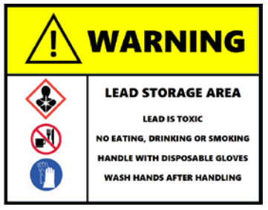
- Store lead in designated, tightly sealed containers separate from any other chemicals and materials.
- Label storage area/container with a sign indicating hazards.
- Use lead signage in lead use area.
Users of chemicals are required to follow labeling requirements when transferring chemicals to secondary containers and when labeling containers with chemical waste. Requirements for labeling containers and templates for creating labels are available on the EH&S website.
Check Section 2 of the Lab Safety Manual and the Chemical Compatibility Chart on the EH&S website for incompatible chemical groups.
Special storage precautions may include keeping away from heat, light, air, flames, sources of ignition.
Check Section 2 of the Lab Safety Manual for information on chemical transport practices.

Section 5 – Spill and accident procedures
REQUIRED - Insert descriptions of any specialized spill clean up procedures for materials used in this SOP.
Spill response procedures must be developed based on the chemical and potential spill or release conditions.
- Spill response procedures must be developed based on the chemical (refer to SDS) and potential spill or release conditions and using the appropriate spill kit.
- Differentiate small vs. large spills, spills in hood vs. outside of hood. For example, spills less than 100mL within fume hood may be safely handled by staff, spills greater than 10mL outside of fume hood may not be handled by staff. Note quantities and concentrations specific for this/these chemical(s).
- Differentiate liquid vs. powder spills: materials and procedures.
- Include appropriate/additional PPE required for spill cleanup. For chemicals that are corrosive and/or toxic by skin contact/absorption, additional protective clothing (e.g., face shield, chemically-resistant apron, disposable sleeves, etc.) are required where splashes or skin contact is foreseeable.
- Determine whether/when EH&S must be contacted: Typically the chemical, conditions, and size of spill will be deciding factors. If in doubt, contact EH&S.
Small spills and releases may be cleaned up with proper PPE using soapy water and paper towels, or a lead removal product. Bag or contain the spilled material and debris, and cleanup materials. Double bag all waste in plastic bags labeled with a hazardous waste label for EH&S pickup.
If a significant spill or release occurs, stop work. Properly protected and trained personnel must clean up spills immediately. All other persons should leave the area. Do not attempt to clean up any spill if not trained, wearing appropriate personal protective equipment, or comfortable.
For large spills, evacuate the area and call 9-1-1* on any campus phone for help.
Clean up spills using contents of the laboratory spill kit: [describe specific types of spill clean-up materials required].
Specify any signage, entry restrictions that are required.
Describe PPE required for cleanup.
For questions on spill cleanup, contact EH&S spill consultants at 206‐543‐0467 during normal business hours (Monday-Friday, 8 a.m. to 5 p.m.).
Any spill, exposure or near miss incident requires the involved person or supervisor to complete and submit the Online Accident Reporting System (OARS) form on the EH&S website within 24 hours (certain types of incidents require immediate notification) at oars.ehs.washington.edu.
Exposures: If a person is injured, exposed, or suspected of being exposed to lead, follow procedures listed here:
INSERT IF APPLICABLE - Descriptions of any specialized emergency procedures for locations outside of a UW campus or facility.
Stop work and perform first aid immediately.
Refer to SDS for additional chemical-specific guidance; include pertinent information here.
- Inhalation exposure: If fumes or dust are inhaled, immediately move to get fresh air. Move out of contaminated area; get medical help.
- Sharps injury (needle stick or subcutaneous exposure): Scrub exposed area thoroughly for 15 minutes using warm water and sudsing soap.
- Skin exposure: Use the nearest safety shower for 15 minutes; stay under the shower and remove clothing; use a clean lab coat or spare clothing for cover‐up.
- Eye exposure: Use the eye wash for 15 minutes while holding eyelids open.
Get Help.
- Call 9-1-1 or go to nearest Emergency Department (ED); provide details of exposure:
    - Agent
    - Dose
    - Route of exposure
    - Time since exposure
- Bring the SDS and this SOP to the Emergency Department
- Notify your supervisor as soon as possible for assistance
- Secure the area before leaving; lock doors and indicate spill if needed
Report the incident to Environmental Health & Safety.
- Notify EH&S immediately after providing first aid and/or getting help.
  - During business hours (M‐F/8‐5), call 206‐543‐7262.
  - Outside of business hours, call 206‐685‐UWPD (8973) to be routed to EH&S Staff On Call.
- The involved person or supervisor submits the UW Online Accident Reporting System (OARS) form on the EH&S website within 24 hours (certain types of incidents require immediate notification) at oars.ehs.washington.edu.
Refer to SDS for additional chemical-specific guidance; include pertinent information here.

Section 6 – Waste accumulation and disposal procedures
REQUIRED - Describe specific waste disposal procedures for all waste streams generated with lead. Include appropriate containment practices, storage locations, and any specific storage or handling practices. If relevant, include instructions for updating chemical inventories.

Refer to the SDS and UW Laboratory Safety Manual, Section 3 for guidance on waste handling, labeling, accumulation, storage and pickup.
Per UW Administrative Policy Statement 11.2, the University of Washington Environmental Health & Safety Department has full responsibility for collection of hazardous waste for the University, all its campuses, and off-site locations; University laboratories cannot contract with an outside vendor to collect hazardous waste.
Be aware that many laboratory accidents happen from inadvertent disposal of incompatible wastes into the same waste container. Therefore, identify different waste streams as appropriate.
Dispose of waste liquids and solids (wet wipes and other debris) as hazardous chemical waste.
Accumulate waste at the point of generation in a properly labeled, sealed, leak-proof container.
Vented lids may be appropriate for certain chemicals. Email labcheck@uw.edu with questions.
Manage chemical and hazardous chemical waste separately from other waste streams such as biohazardous waste. Never autoclave chemical waste because it can produce hazardous chemical vapors, aerosols, and explosive reactions.
All chemical waste containers must be labeled with a UW Hazardous Waste Label. Refer to How to Label Chemical Waste Containers.
To request a collection of chemical waste, submit a form on the Chemical Waste Disposal webpage on the EH&S website or directly in MyChem inventory. Contact EH&S at 206.616.5835 or chmwaste@uw.edu with questions.
For metallic lead that can be recycled, go to the Recycling Metals webpage for information
Visit the Hazardous Material Disposal and Recycling webpage on the EH&S website for information on disposing, recycling and surplusing materials.

Section 7 – Protocol (Add lab specific Protocol/Procedure here)
REQUIRED - Insert or attach detailed laboratory-specific procedures for the process, hazardous chemical(s), or hazard class. You may also include any relevant supporting resources such as journal citations, etc. that are applicable.
Refer to Section 2 of the UW Laboratory Safety Manual on the EH&S website for additional guidance on chemical management and preparation for use for particularly hazardous substances (PHSs).
NOTE: Any deviation from this SOP requires approval from Principal Investigator.

Section 8 – Special Precautions for animal use (___Yes ___No)
Use of [chemical], in animals will be documented and approved by IACUC.
Annotate “N/A” if no animal exposure is involved. If chemicals are being administered to animals, describe how employees should protect themselves from contaminated animals and animal waste below. Include all restricted access, chemical administration, aerosol suppression, PPE, and waste disposal procedures required.
Describe how employees should protect themselves from contaminated animals and animal waste.
PARTICULARLY HAZARDOUS SUBSTANCE INVOLVED?
YES: Sections #9 to #11 are Mandatory
EH&S flags Particularly Hazardous Chemicals in MyChem based on hazards.

Section 9 – Approvals required
Complete of Lead Awareness (online) training prior to working with lead: https://www.ehs.washington.edu/training/lead-awareness-%E2%80%93-online
All staff working with lead must be trained on this SOP prior to starting work. They must also review the SDS, and it must be readily available in the laboratory. All training must be documented and maintained by the PI or their designee.
Describe any requirements for obtaining authorization before use of the chemical for the procedure, operation, or activity can be performed.
Examples:
- A worker must have [specific training] documented before performing described procedure for the first time.
- A medical examination must be completed prior to respirator use (for lead, dust, pathological organisms).
- Other authorizations required before a person can independently perform a process using a particularly hazardous substance.

Section 10 – Decontamination
Include work area decontamination procedures as appropriate for use:
Wet-wipe all lead-contaminated surfaces with soapy water and paper towels, or a lead removal product. Dispose of clean-up materials as hazardous waste.
REQUIRED - Insert descriptions of decontamination procedures for specific equipment, glassware, and controlled areas (e.g., glove boxes, restricted access hoods, fume hoods, or designated portions of the laboratory) where lead used.

Section 11 – Designated area

REQUIRED - Identify specific areas where the particularly hazardous chemicals may be used (e.g., glove boxes, restricted access hoods, perchloric/hot acid fume hoods, or designated portions of the laboratory).

Section 12 – Documentation of training (signature of all users is required)
- Prior to using substances included in this SOP, laboratory personnel must be trained on the hazards described in this SOP, how to protect themselves from the hazards, and emergency procedures.
- Ready access to this SOP and to a Safety Data Sheet for each hazardous material described in the SOP must be made available in the lab space(s) where these substances are used.
- The Principal Investigator (PI), or Responsible Party, if the activity does not involve a PI, must ensure that their laboratory personnel have attended appropriate laboratory safety training (and refresher training where applicable).
- Training must be repeated following any revision to the content of this SOP.
- Training must be documented. This training sheet is provided as one option; other forms of training documentation (including electronic) are acceptable but records must be accessible and immediately available upon request.
I have read and understand the content of this SOP:
Name | Signature | Date

